Project Design Phase Solution Architecture

Date | 11 February 2026
Team ID | LTVIP2026TMIDS88533
Project Name | Explore with AI: Custom Itineraries for Your Next Journey
Maximum Marks | 2 Marks
Solution Architecture:

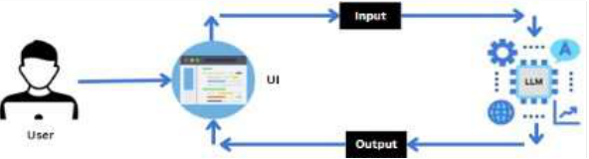

1. Overview
Explore with AI is a web and mobile-based platform that allows users to enter travel preferences (destination, duration, interests) and receive a personalized, AI-generated travel itinerary. The system is designed for simplicity, speed, and scalability.
2. High-Level Components
A. User Interface (Frontend)
• Technology: Streamlit (Python) or React.js for web/mobile interface• Functionality:
o Input fields for destination, trip duration, and preferences/interests
o Submit button to generate itinerary
o Display of AI-generated itinerary in a structured, day-wise format
o Options to review, customize, or export itinerary (PDF/Text)
o Display user-friendly error messages
B. API Layer / Backend
• Technology: Python (Flask/FastAPI)• Functionality:
o Receives user input from frontend

o Validates inputs (destination, dates, preferences)
o Handles requests to the AI model
o Returns structured itinerary results to frontend
C. AI Engine
• Technology: Gemini Pro LLM / OpenAI GPT / other generative AI model• Functionality:
o Processes input parameters (destination, duration, interests)
o Generates detailed day-wise itinerary including:
▪ Attractions and sightseeing
▪ Local dining recommendations▪ Suggested activities and timing
▪ Travel tips and optional hidden gems
o Ensures structured output for easy rendering on frontend
D. Data Layer (Optional)
• Technology: Cloud database (MongoDB/PostgreSQL)• Functionality:
o Stores predefined destination data (optional)
o Stores user-generated itineraries (if history/export feature is implemented)
o Logs analytics for system monitoring
E. Export & Reporting Module
• Functionality:
o Convert itinerary to PDF or downloadable formats
o Copy/export to clipboard
o Optional integration with email or messaging for sharing
3. Key Features of Architecture
• Modular Design: Frontend, backend, AI engine, and data layer are loosely coupled.• Scalable: Can handle more destinations, multiple users, and AI requests
simultaneously.
• Extensible: Future features can include multi-destination planning, travel booking integrations, or content generation for blogs.
• Simple Workflow: Focused on input→AI processing→output, minimizing user friction.

